**Data Quality Assessment**

1. Data has unnecessary empty column with Nan Values.
2. There are multiple missing Values in some data columns.

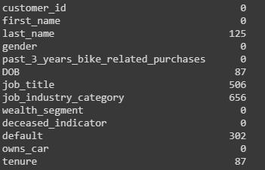

1. Inconsistency in the Column gender .



1. Inaccurate Details in the column DOB ,as a result some observation have age greater than 170 years which is impossible and inaccurate.

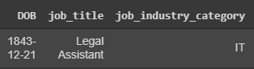

1. Job title and job industry details are missing for a large portion of customers.
2. Wealth segment , owns car and deceased indicator are three columns which have perfect data and need no pre-processing.
3. Column default filled with some random data and it has no part to play with the data analysis ,this column can be eliminated completely.

